Sri Lanka Institute of Information

Technology



Lab Submission

<Lab sheet No 07>

**<IT24101556>**

**<Bamunusinghe B.A.I.B.T>**

**Probability and statistics**

B.Sc. (Hons) in Information Technology

Exercise

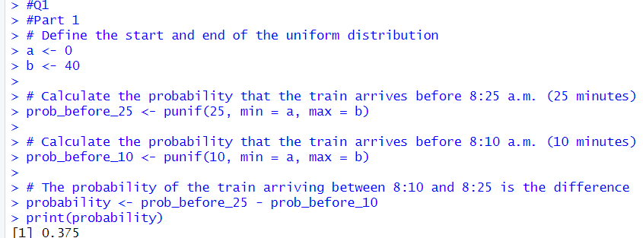Q1) 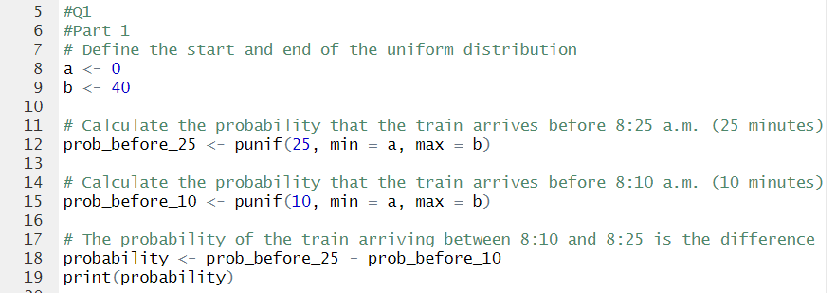

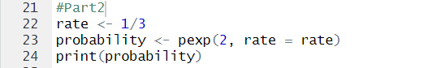Q2)

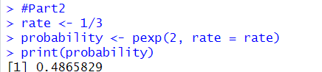

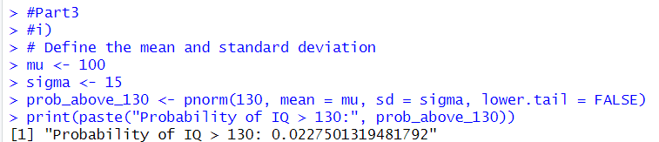Q3) i) 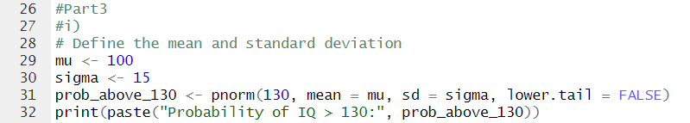

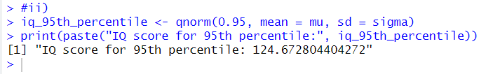ii) 